Sally’s Meadow, East Burton BH20 6HL

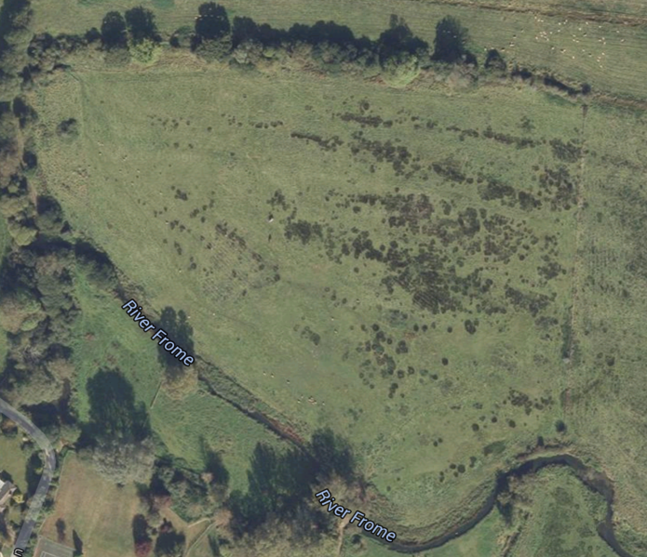

Marketed by
Maxgate Properties
17 Weymouth Avenue
Dorchester
DT1 1QT
01305 251400

